H.T No
Regulations:
A18

Sreenidhi Institute of Science and Technology
(An Autonomous Institution)
Code No: 7AC02 Date: 05-Feb-2024 (AN)

B.Tech I-Year I- Semester External Examination, Jan/Feb-2024 (Supplementary)
NETWORK ANALYSIS (ECE)

Time: 3 Hours Max.Marks:70

Note: a) No additional answer sheets will be provided.
b) All sub-parts of a question must be answered at one place only, otherwise it will not be valued.
c) Missing data can be assumed suitably.
Bloom's Cognitive Levels of Learning (BCLL)

Remember | L1 | Apply | L3 | Evaluate | L5
Understand | L2 | Analyze | L4 | Create | L6

Part - A Max.Marks:20

Answer all QUESTIONS.

 |  | BCLL | CO(s) | Marks
1 | What are dependent and independent sources? | L2 | CO1 | [2M]
2 | Define graph and incidence matrix. | L2 | CO2 | [2M]
3 | What is leakage flux? | L1 | CO3 | [2M]
4 | What is meant by complex power? | L2 | CO4 | [2M]
5 | Define Half power frequencies and quality factor. | L2 | CO5 | [2M]
6 | What are the limitations of maximum power transfer theorem? | L1 | CO6 | [2M]
7 | Explain the purpose of star delta transformation. | L1 | CO1 | [2M]
8 | What are the advantages of sinusoids? | L2 | CO4 | [2M]
9 | Write the characteristics of series and parallel resonance. | L1 | CO6 | [2M]
10 | State the dot rule for coupled circuits. | L2 | CO3 | [2M]

Part – B Max.Marks:50
ANSWER ANY FIVE QUESTIONS. EACH QUESTION CARRIES 10 MARKS.

 |  |  | BCLL | CO(s) | Marks
11. | a) | Find the power delivered by the voltage and the current source in the circuit shown in fig  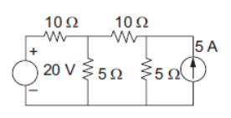 | L3 | CO1 | [5M]
 | b) | Determine the current delivered by the source in the circuit shown in fig  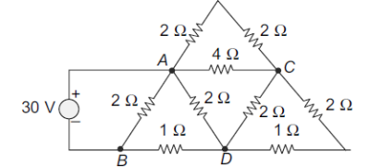 |  |  | [5M]
12. |  | Find the node voltages in the circuit. Prepare the network graph with the reference direction for currents as marked in the fig.  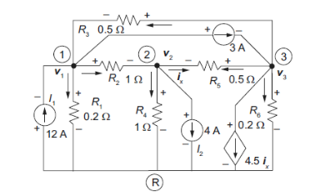 | L3 | CO2 | [10M]
13. | a) | In the coupled circuit find the voltage across the 5Ω resistor.  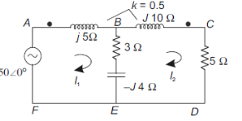 | L3 | CO3 | [5M]
 | b) | Calculate the mmf required to produce a flux of 5mWb across an air gap of 2.5mm of length having an effective area of 100cm² of cast steel ring of mean iron path of 0.5m and cross sectional area of 150 cm² as shown in fig. The relative permeability of cast steel is 800. Neglect leakage flux.  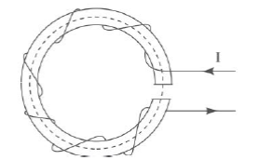 | L3 | CO3 | [5M]
14. |  | Explain the rms value and average value of alternating quantity. Derive its necessary expressions. | L2 | CO4 | [10M]
15. | a) | For the circuit shown in fig. The applied voltage v(t) = 15 sin 1800t. Determine the resonant frequency. Calculate the quality factor and bandwidth. Compute the lower and upper limits of bandwidth.  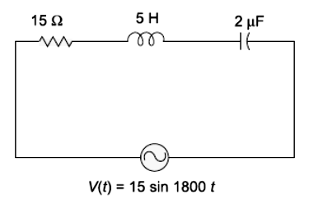 | L3 | CO5 | [5M]
 | b) | For a parallel circuit shown in fig. Plot the locus of currents.  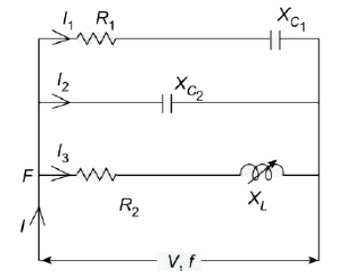 |  |  | [5M]
16. |  | Find voltage across the 10Ω and power dissipated in all resistors by using superposition principle in the circuit shown.  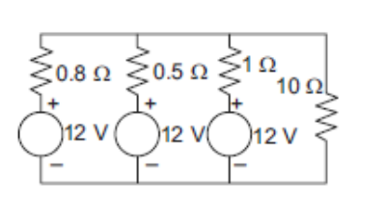 | L3 | CO6 | [10M]
17. | a) | Explain the concept of supernode and supermesh | L2 | CO1 | [4M]
 | b) | Draw the graph represented by the matrix A  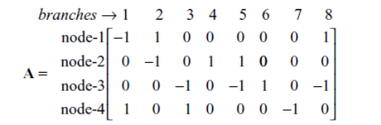 | L3 | CO2 | [3M]
 | c) | Two inductively coupled coils have self-inductance L₁ = 50 mH and L₂ = 200 mH, if the coefficient of coupling is 0.5, compute the value of mutual inductance between the coils. | L3 | CO3 | [3M]
18. | a) | For the parallel circuit shown in fig, find the currents and the total current and construct the phasor diagram.  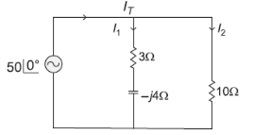 | L3 | CO4 | [5M]
 | b) | Derive the expression for Bandwidth of a series RLC circuit. | L4 | CO5 | [5M]
-- 00 -- 00 –

